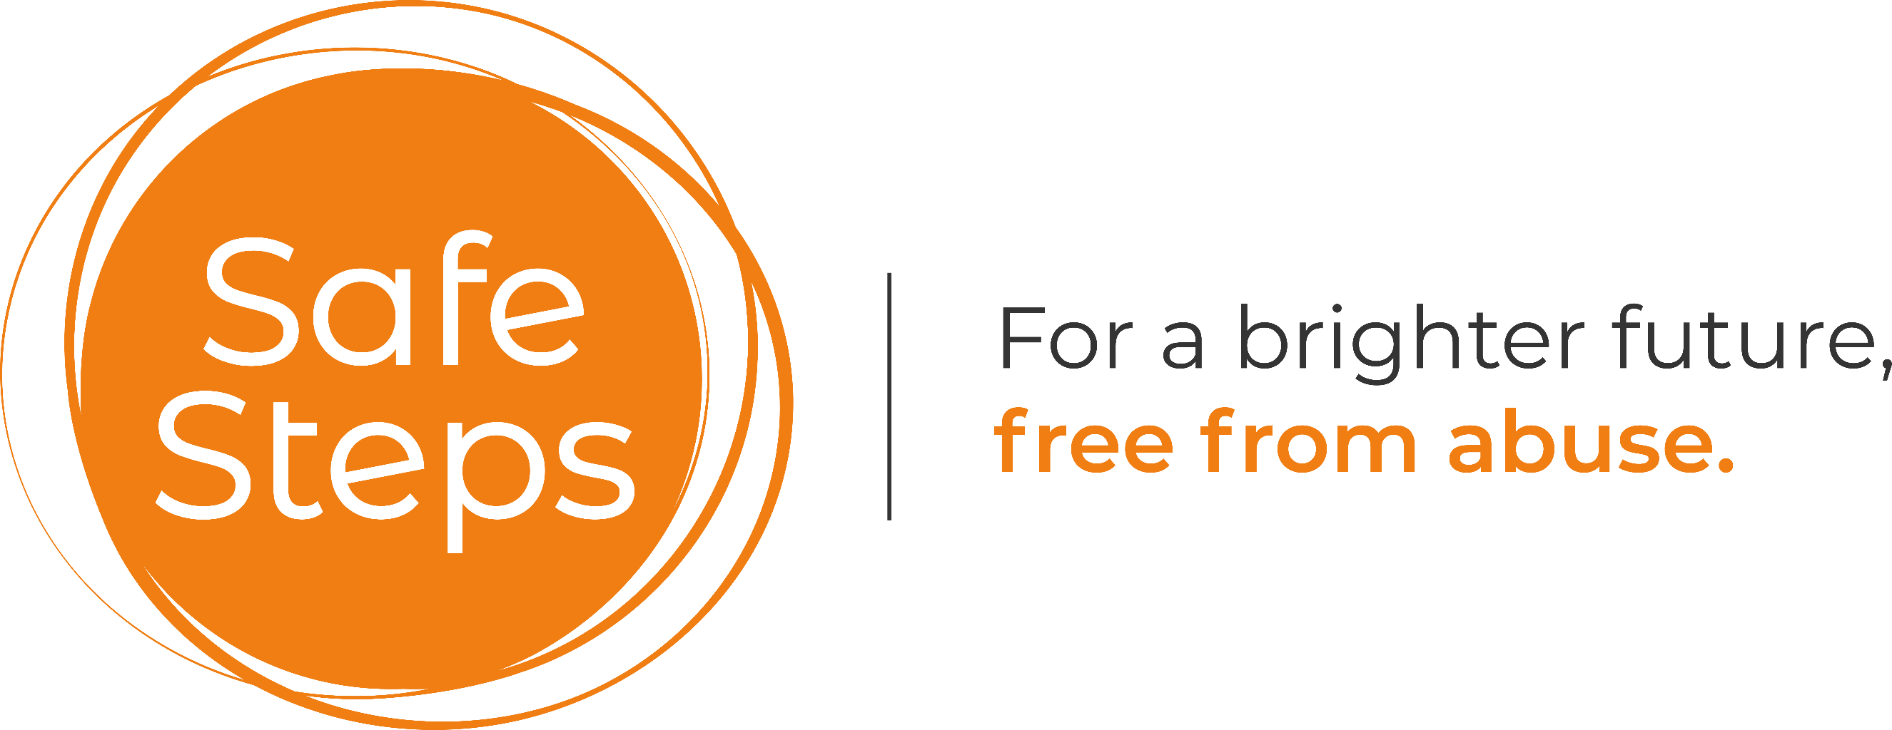

Safe Steps

Website Privacy and Cookie Policy

Registered charity number: 1177687

Policy Owner: Safe Steps
Policy approved by: Safe Steps Trustees
Date Policy approved:
Next review Date:

Privacy Policy

Safe Steps are committed to protecting and respecting your and your children’s privacy. The purpose of this policy is to explain what information we collect, how we use the personal information and keep it secure, and the conditions under which we may disclose it to others.

How we collect personal information about you

We may collect personal information from you when you contact SEAS to access a service, make a donation, apply for a job or volunteering opportunity. This information can be obtained through post, email, telephone or in person.

What information do we collect?

The personal information we collect may include:

- Name
- Address
- Date of birth
- Email address
- Telephone numbers
- Other relevant information about you, that you provide to us

What Information we use

- We will hold your personal information on our systems for as long as is necessary for the relevant activity, or as long as is set out in any consent letter, or relevant contract you hold with us
- To receive feedback, views or comments on the services we provide
- To process an application (for a job or volunteering opportunity)

If you provide us with any sensitive personal data by telephone, email or by other means, we will treat that information with extra care and always in accordance with this Privacy Policy. Personal information and other information you provide to us is stored on a secure database for no longer than is necessary. We carry out periodic deletion of data when the data is no longer required, or the retention period has expired.

Who sees your personal information?

The personal information we collect about you will be used by our staff and volunteers, and with your prior consent, organisations that work with us to deliver services to support you and your children, and if required by law, legal and regulatory authorities.

In exceptional circumstances, information will be shared:​

- Where it is in the interests of personal or public safety
- If we have concerns about your safety or that of your children, we will have to share this information with other agencies such as Social Care
- Where disclosure may prevent serious harm to an individual or others
- If ordered to do so by a court of law or to fulfil a legal requirement

We will endeavour to notify you of this action in such cases and we will never sell your personal information to other organisations for marketing purposes.

You can withdraw your consent for us to use your personal information at any time, however this may however affect our ability to communicate effectively with you about your support.

How long do we keep the data?

We will keep your data for up to a period of 7 years and up to 21 for children, following your last engagement with us. If you wish to know what data we hold about you or you wish to amend the data we hold, you should submit a request in writing to either your Domestic Abuse Support Practitioner or to the Data Controller (the Chief Executive) at the following address:

Safe Steps, 4 West Road, Westcliff, Essex SS0 9DA or email: enquiries@safesteps.opg

How is data stored

All confidential data is stored electronically on our Client Database. Access to this is controlled to named staff who have individual and approved passwords only. Strict policies are enforced around the access and use of data within Safe Steps.

Further information

If you have any clause for complaint or feel that your data has been used or shared inappropriately, you should contact the Chief Executive (or Data controller) in the first instance.
enquiries@safesteps.org or telephone 01702 868026
If appropriate, you will be sent a copy of our Complaints Policy.

Legal obligations

Safe Steps is a data controller for the purposes of the Data Protection Act 1988 and the EU General Data Protection Regulation 2016/679 9Data Protection Law). This means that we are responsible for the control and the processing of your personal information.

Cookie Policy

Cookies and how you use this website

To make this website easier to use, we sometimes place small text files on your device (for example your iPad or laptop) called “cookies”. Most big websites do this too. They improve things by:

- remembering the things you have chosen while on our website, so you do not have to keep re-entering them whenever you visit a new page
- remembering data you have given (for example, your address) so you do not need to keep entering it
- measuring how you use the website so we can make sure it meets your needs
By using our website, you agree that we can place these types of cookies on your device. We do not use cookies on this website that collect information about what other websites you visit (often referred to as “privacy intrusive cookies”). Our cookies are not used to identify you personally. They are just here to make the site work better for you. You can manage and/or delete these files as you wish.

What types of cookies do we use?

- Essential: Some cookies are essential for you to be able to experience the full functionality of our site. They allow us to maintain user sessions and prevent any security threats. They do not collect or store any personal information.
- Statistics: These cookies store information like the number of visitors to the website, the number of unique visitors, which pages of the website have been visited, the source of the visit etc. This data helps us understand and analyse how well the website performs and where it needs improvement.
- Functional: These are the cookies that help certain non-essential functionalities on our website. These functionalities include embedding content like videos or sharing contents on the website on social media platforms.
- Preferences: These cookies help us store your settings and browsing preferences like language preferences so that you have a better and efficient experience on future visits to the website.

How can I control the cookie preferences?

Different browsers provide different methods to block and delete cookies used by websites. You can change the settings of your browser to block/delete the cookies. To find out more out more on how to manage and delete cookies, visit wikipedia.org, www.allaboutcookies.org.

Further guidance on the use of personal information can be found at ico.org.uk.

