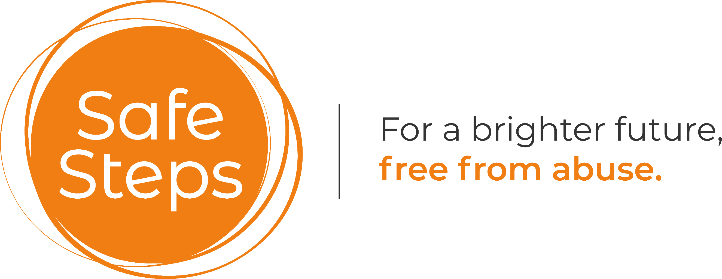

Safe Steps

Data Protection Statement

Registered charity number: 1177687

Policy Owner: Safe Steps
Policy approved by: Safe Steps Trustees
Date Policy approved:
Next review Date: Every 3 years

Data Protection Statement

Safe Steps is registered with the Information Commissioner’s Office (Registration No. ZA796524). We treat all information and data we receive from our clients with the utmost respect. Under our Data Protection Policy, we agree that:

- The information we collect and retain from you will be relevant to the service we provide.
- No personal information will be revealed, or shared with a third party without gaining your consent in advance. A third party relates to another professional that we think may be able to help you.
- We would have a duty of care to divulge your personal information without your consent, in a situation that was either: criminal, of national security, life-threatening to you or to safeguard a child or vulnerable adult. These are the only instances where we would do this.
- All paper records and files will be secured in a safe place.
- All computerised records, emails and any other information will be password-protected and our computers have the following software installed to provide additional protection: anti-virus, anti-spyware and firewall. Laptops used within the organisation are also encrypted.

Retention periods

Safe Steps will store your personal information for 7 years (21 years for children) or until such time that you ask for it to be deleted/destroyed. Where there may be a safeguarding issue, we may refuse deletion or retain the information for a number of years further. These retention periods are in line with our Data Protection Policy.
Requests for information

You have the right to request to see any information Safe Steps holds about you.
If you wish to make a request, please contact us. The General Data Protection Regulation (GDPR) allows most subject access requests to be made free of charge. However, we may charge a reasonable fee for further copies of the same information, when a request is excessive, particularly if it is repetitive. The fee would be based upon the administrative cost of providing the information. We will respond without delay, and at the latest, within one month of receipt.

